GESTURE RECOGNIZING ROBOT

SUBMITTED BY
- PRERNA .S .BAKHRU
- RESHMA. K. RAMANAN
- CHANDNI .S. KATEJA
4. BHAGYASHREE.B.PATIL

WATUMULL INSTITUTE OF ELECTRONICS ENGG. &
COMPUTER TECHNOLOGY, WORLI, MUMBAI- 400018.
[ UNDER UNIVERSITY OF MUMBAI]

TABLE OF CONTENT:
INDEX OF FIGURES: 3
ABSTRACT 4
1.INTRODUCTION 5
2. BLOCK DIAGRAM 7
3. REQUIREMENT DETAILS 9
3.1. HARDWARE DETAILS 9
I. MS KINECT KIT 9
II. SPARK V : 11
III. XBEE WIRELESS MODULE……………………………………………………………………………………………..13
3.2 SOFTWARE DETAILS 14
VISUAL STUDIO 14
KINECT SDK 16
4.A METHODOLOGY USED IN THE PROJECT: 18
5. CHALLENGES 23
6. CONCLUSION 24
7. APPLICATIONS 25
8. REFERENCES………………………………………………26

INDEX OF FIGURES:
1. BASIC WORKING OF KINECT SENSOR………………..5
2. BLOCK DIAGRAM OF BASIC GESTURE
RECOGNITION SYSTEM…………………………………..7
3. KINECT EXAMPLE PROGRAM ………………………….10
4. BASIC SPARK V ROBOT…………………………………..11
5. XBEE WIRELESS MODULE………………………………..13
6. DIAGRAM SHOWING SKELETAL TRACKING IN
KINECT……………………………………………….. …...18

ABSTRACT
Hand gesture based Human-Computer-Interaction (HCI) is one of the most natural and intuitive ways to communicate between people and machines, since it closely mimics how human interact with each other. In this demo, we present a hand gesture recognition system with Kinect sensor, which operates robustly in uncontrolled environments and is insensitive to hand variations and distortions. Our system consists of two major modules, namely ,gesture recognition and robot movement. Different from traditional vision-based hand gesture recognition methods that use color-markers for hand detection, our system uses both the depth and color information from Kinect sensor to detect the hand shape, which ensures the robustness in cluttered environments. Consequently, our system operates accurately and efficently. In this demo, we demonstrate the performance of our system on SPARK V robot.

1.INTRODUCTION

Hand gesture recognition is an important research issue in the ﬁeld of Human-Computer-Interaction, because of its extensive applications in virtual reality, sign language recognition, and computer games [7]. Despite lots of previous work, building a robust hand gesture recognition system that is applicable for real-life applications remains a challenging problem. Existing vision-based approaches [1, 5, 6] are greatly limited by the quality of the input image from optical cameras. Variations in lighting and background clutters would only worsen the problem. Consequently, these systems have not been able to provide satisfactory results for hand gesture recognition.

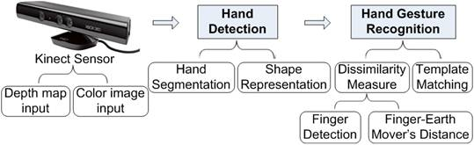
Fig 1: BASIC WORKING OF KINECT SENSOR
Gestures can originate from any bodily motion or state but commonly originate from the face or hand. Current focuses in the field include emotion recognition from the face and hand gesture recognition. Many approaches have been made using cameras and computer vision algorithms to interpret sign language. The identification and recognition of posture, gait, human behaviors is also the subject of gesture recognition
Hand gesture recognition concerns two challenging problems: hand detection and gesture recognition, namely how to robustly detect the hand and how to efficently and accurately recognize the gesture of the hand.framework of our hand gesture recognition system is shown in Fig.1.
As for hand detection, different from traditional methods that use color-markers for hand detection, our system uses both the depth map and color image obtained by Kinect sensor to detect the hand shapes. It ensures robustness to cluttered background. And the segmented hand shapes are represented as time-series curves [2].As for the gesture recognition, even with the Kinect sensor, it is still a very challenging problem. Because typically, the resolution of a Kinect sensor is only 640480.
Although it works well to track a large object, e.g. the human body, it is diﬃcult to detect and segment precisely a small object from an image at this resolution, e.g., a human hand that occupies a very small portion of the image. Therefore, we use a novel shape distance metric called Finger-Earth Mover’s Distance (FEMD) to measure the dissimilarities between different hand shapes, which is proposed in [4]. The kinect sensor instead of using intensive processing of the 3D models and dealing with a lot of parameters uses a simplified version of joint angle parameters along with segment lengths for tracking of whole body. This method is known as a skeletal representation of the body, where a virtual skeleton of the person is computed and parts of the body are mapped to certain segments.

2. BLOCK DIAGRAM

The block diagram of the basic gesture recognition system is given as below:
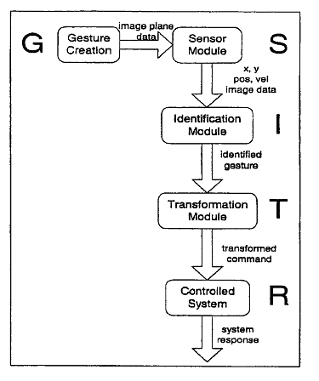
Fig 2: BLOCK DIAGRAM OF BASIC GESTURE
RECOGNITION SYSTEM

The explanation of different modules can be given as follows:
SENSOR MODULE:
The sensors (camera and depth sensors)on the Kinect kit senses the real time hand gestures and converts it into image data .
IDENTIFICATION MODULE:
This module identifies the hand gestures by comparing with the stored image database using Pattern Matching. The region showing the gesture is cropped out and the image is resized to match with the gestures in the database.
TRANSFORMATION MODULE:
It transforms the sensed gesture into proper control commands for robot using different algorithms. The selected instruction set, corresponding to recognized hand gesture is given to robot for carrying out the control action.
CONTROL MODULE:
The final module where the proper control actions are performed on the robots as per the identified gestures.

APPLICATIONS OF GESTURE RECOGNITION SYSTEMS:
A gesture recognition system could be used in any of the following areas: Man-machine interface: using gestures to control the computer mouse and/or keyboard .
3D animation: Rapid and simple conversion of hand movements into 3D computer space for the purposes of computer animation. Computer games: Using the hand to interact with computer games would be more natural for many applications.
Control of mechanical systems (such as robotics): Using the hand to remotely control a manipulator.

3. REQUIREMENT DETAILS

3.1. HARDWARE DETAILS

I. MS KINECT KIT
The Kinetic Space provides a tool which allows everybody to record and recognize customized gestures using depth images. The software observes and comprehends the user interaction by processing the skeleton of the user. The unique analysis routines allow to not only detect simple gestures such as pushing, clicking, forming a circle or waving, but also to recognize more complicated gestures as, for instance, used in dance performances or sign language.
It features an RGB camera, a depth sensor and multi-array microphone running proprietary software which provides full-body 3D motion capture, as well as face and voice recognition. The depth sensor consists of an infrared laser projector combined with a monochrome CMOS sensor, which captures video data in 3D under any ambient light conditions. The sensing range of the depth sensor is adjustable,
It consists of a motor for the infrared light sensors, a camera part which takes color image as an input and a stereo microphone for the speech recognition. As an infrared transmission module from infrared sensor parts shoots the object in a cross stripes pattern, it gathers the distance information from a staff to measure a distortion degree by receiving infrared light with an infrared camera.
From left to right, the figure 2 shows the Depth Map screen by measuring the distance information, a skeleton information screen extracted by recognizing the shape of the man, through the color image camera. Since the distance information map is processed only with an infrared ray’s sensor, it is dramatically less time consuming compare to the older methods such as a stereo vision technique or the multi-image system.
When you see the figure in the middle, after recognizing the shape of the man using distance information Map and applying these to the skeleton algorithm, the system shows the skeleton.

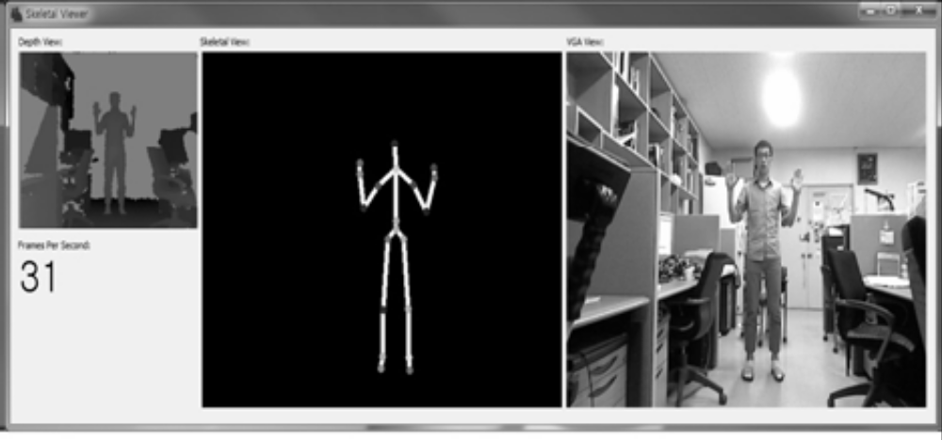
Fig.3 KINECT EXAMPLE PROGRAM

Kinect is capable of simultaneously tracking up to six people, including two active players for motion analysis with a feature extraction of 20 joints per player. However, PrimeSense has stated that the number of people the device can "see" is only limited by how many will fit in the field-of-view of the camera.
. The RGB video stream uses 8-bit VGA resolution (640 × 480 pixels) with a Bayer color filter, while the monochrome depth sensing video stream is in VGA resolution (640 × 480 pixels) with 11-bit depth, which provides 2,048 levels of sensitivity.
The Kinect sensor has a practical ranging limit of 1.2–3.5 m (3.9–11 ft) distance. The area required for Kinect is roughly 6m², although the sensor can maintain tracking through an extended range of approximately 0.7–6 m (2.3–20 ft). The sensor has an angular field of view of 57° horizontally and 43° vertically, while the motorized pivot is capable of tilting the sensor up to 27° either up or down. The horizontal field of the Kinect sensor at the minimum viewing distance of ~0.8 m (2.6 ft) is therefore ~87 cm (34 in), and the vertical field is ~63 cm (25 in), resulting in a resolution of just over 1.3 mm (0.051 in) per pixel.
The microphone array features four microphone capsules and operates with each channel processing 16-bit audio at a sampling rate of 16 kHz.

II. SPARK V :

Spark V is a low cost robot designed for robotics hobbyists and enthusiasts. It is jointly designed by NEX Robotics with Department of Computer Science and Engineering, IIT Bombay.Robot programming is done using NEX Robotics Boot loader via USB port. Robot has onboard socket for zigbee wireless module for multi robot and robot to PC communication. Robot has two low power 60 RPM DC geared motors which are powered by L293D motor driver with the top speed of 66cm/second.

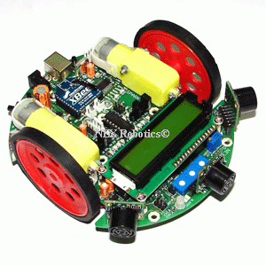
Fig 4: BASIC SPARK V ROBOT.

SPARK V
Technical specification:
Microcontroller: ATMEL ATMEGA16
Sensors:
Three white line sensors
Three IR proximity sensors
Three directional light intensity sensors
Two Position Encoders (optional)
MaxBotix EZ series ultrasonic range sensors (optional)
Servo mounted Ultrasonic Range Sensor (optional)
Battery voltage sensing.( 7.2 V 600 mA rechargeable NiMH battery)

Software Support:
GUI Based control, AVR studio, WINAVR.
Microsoft robotics studio Visual Programming Language

Operational Modes:
Standalone (Autonomous Control)
PC as master and robot as slave
Distributed (multi robot communication)

III. XBEE WIRELESS MODULE
XBee wireless module is used for communicating with other robots and PCs. ATMEGA16 microcontroller has one serial port which can be connected to USB port via FT232 USB to Serial converter or to XBee wireless module. To connect XBee wireless module with the microcontroller, you need to set Jumper J5 in correct setting. In this setting J5 connects TXD and RXD pins of the microcontroller with the XBee wireless module.

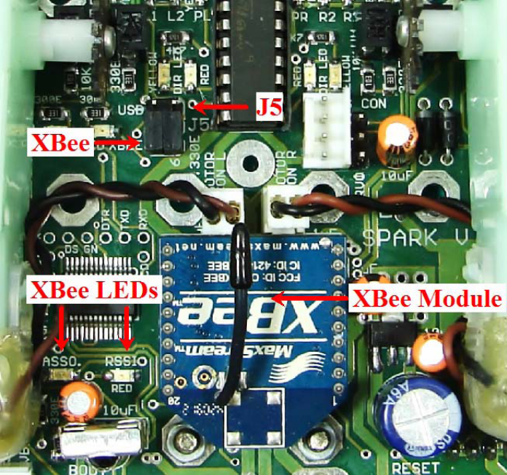

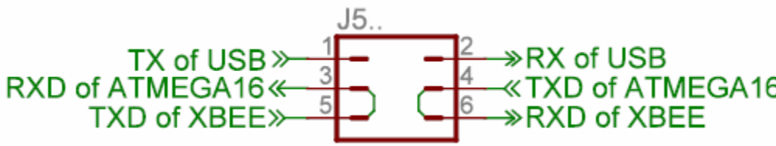
Fig 5: XBEE WIRELESS MODULE
Figure shows jumper setting for connecting XBee wireless module to the ATMEGA16 microcontroller. “ASSO” LED shows the association over the network. “RSSI” LED shows the strength of the wireless signals..

3.2 SOFTWARE DETAILS

VISUAL STUDIO
Microsoft Visual Studio is an integrated development environment (IDE) from Microsoft. It is used to develop console and graphical user interface applications along with Windows Forms applications, web sites, web applications, and web services in both native code together with managed code for all platforms supported by Microsoft Windows, Windows Mobile, Windows CE, .NET Framework, .NET Compact Framework and Microsoft Silverlight.
Visual Studio supports different programming languages by means of language services, which allow the code editor and debugger to support nearly any programming language, provided a language-specific service exists. Built-in languages include C/C++ (via Visual C++), VB.NET (via Visual Basic .NET), C# (via Visual C#), and F# (as of Visual Studio 2010^{[3]}). Support for other languages such as M, Python, and Ruby among others is available via language services installed separately. It also supports XML/XSLT, HTML/XHTML, JavaScript and CSS. Individual language-specific versions of Visual Studio also exist which provide more limited language services to the user: Microsoft Visual Basic, Visual J#, Visual C#, and Visual C++.
Microsoft Visual C# is one of the supported products of visual studio.Microsoft's implementation of the C# language, targets the .NET Framework, along with the language services that lets the Visual Studio IDE support C# projects. While the language services are a part of Visual Studio, the compiler is available separately as a part of the .NET Framework. The Visual C# 2008 and 2010 compilers support versions 3.0 and 4.0 of the C# language specifications, respectively. Visual C# supports the Visual Studio Class designer, Forms designer, and Data designer among others.

AVR BOOT LOADER

The AVR Boot Loader (AVRBL) is a bootstrap loader that, once programmed into the
AVR boot-block memory area, allows reprogramming of AVR microcontrollers without
need for a chip programmer. The AVRBL makes use of the self-programming features
of the AVR microcontrollers to allow in-circuit reprogramming. Once the AVRBL is
programmed into the microcontroller, it remains resident until the chip is erased.
Application programs require only a very minimum software interface to use the
AVRBL.
The scope and intent of this product is to provide a “quick start” to
get your product supporting a self-programming capability. Included in the package, with
the boot loader project, is a simple Windows application that allows you to download
an Intel formatted “.hex” file to your product from a PC serial communications port.
All AVR microcontrollers can be programmed using various methods such as In System Programming (ISP), parallel programming and boot loading etc. Advantage with the boot loader is that you don’t need any external hardware to load .hex file on the microcontroller. Almost all the AVR microcontroller based robots and development boards from the NEX Robotics supports this bootloader. To run AVR Boot Loader you will also need Microsoft .net framework version 2, 3 and upwards.

AVR STUDIO 5
Atmel AVR Studio 5 is the Integrated Development Environment (IDE) for developing and debugging embedded AVR applications. The AVR Studio 5 IDE gives you a seamless and easy-to-use environment to write, build, and debug your C/C++ and assembler code

KINECT SDK
The Kinect for Windows SDK beta is a starter kit for applications developers that includes APIs, sample code, and drivers. This SDK enables the academic research and enthusiast communities to create rich experiences by using Microsoft Xbox 360 Kinect sensor technology on computers running Windows 7.
The SDK includes following features:
- Raw sensor streams
Access to raw data streams from the depth sensor, color camera sensor, and four-element microphone array enables developers to build upon the low-level streams that are generated by the Kinect sensor.
- Skeletal tracking
The capability to track the skeleton image of one or two people moving within the Kinect field of view make it easy to create gesture-driven applications.
Skeletal Viewer—Capturing Data with the NUI API (C++ and C#)
The Kinect sensor includes two cameras: one delivers depth information and the other delivers color data.Depth data coming from the Kinect camera and a process called skeletonization is done.The NUI API enables applications to access and manipulate this data. It detects individual users who are within view of the camera and then tracks the positions of their bodies.
All of a sudden, as a programmer, rather than having access to the pixels of a flat image, or even the depth information from the raw Kinect data, you now have a description of your users as a series of joints in space. For many applications, especially gesture-based interfaces and motion capture, this is exactly the data you need to get started. The SkeletalViewer sample uses the NUI API to render data from the Kinect sensor’s cameras as images on the screen.
- Advanced audio capabilities
Audio processing capabilities include sophisticated acoustic noise suppression and echo cancellation, beam formation to identify the current sound source, and integration with the Windows speech recognition API.
- Sample code and documentation
The SDK includes more than 100 pages of technical documentation. In addition to built-in help files, the documentation includes detailed walkthroughs for most samples provided with the SDK.
- Easy installation
The SDK installs quickly, requires no complex configuration, and the complete installer size is less than 100 MB. Developers can get up and running in just a few minutes with a standard standalone Kinect sensor unit (widely available at retail outlets)

SKELETAL TRACKING :
- Instead of using intensive processing of the 3D models and dealing with a lot of parameters, one can just use a simplified version of joint angle parameters along with segment lengths.
- This is known as a skeletal representation of the body, where a virtual skeleton of the person is computed and parts of the body are mapped to certain segments.
- The analysis here is done using the position and orientation of these segments and the relation between each one of them.eg: for example the angle between the joints and the relative position or orientation.

ADVANTAGES OF SKELETAL TRACKING:

- Algorithms are faster because only key parameters are analyzed.
- Pattern matching against a template database is possible.
- Using key points allows the detection program to focus on the significant parts of the body. For example hand in our case.

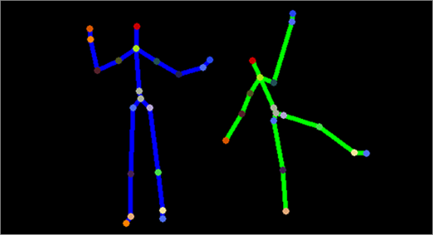
Fig 6: DIAGRAM SHOWING SKELETAL TRACKING

4. METHODOLOGY USED IN THE PROJECT:
Proposed methodology is able to use live video camera for gesture identification. It sniffs frames of live video stream in some time interval. In our case frame capture rate for gesture search is 3 frames per second. Proposed technique to control robotic system using hand gesture display is divided into four subparts:
• Capture frame containing some gesture presentation.
• Extract hand gesture area from captured frame.
• Determine gesture by pattern matching using PCA algorithm
• Determine control instruction, corresponding to matched gesture, and give that instruction to specified robotic system.

The bot will be initially programmed to follow simple four instructions
- FORWARD
- BACKWARD.
- LEFT.
- RIGHT.
Further we also plan to define gestures such as SPEED UP and SLOW DOWN using gestures.

Step1:
Write appropriate code for Spark V ATMEGA16 robot in AVR STUDIO. compile this code to generate the hex file which we will load on the Robot’s microcontroller. Select “Build” menu and click on “Rebuild All”. It will compile the code and will generate corresponding hex file for the robot’s microcontroller. we can later debug the code by AVR Debugger.

Step 2:
AVR Bootloader software which is installed on the PC communicates with the microcontroller. Boot loader software loads the .hex file on the microcontroller. After the boot loading process is complete, newly loaded code can be executed by pressing reset.

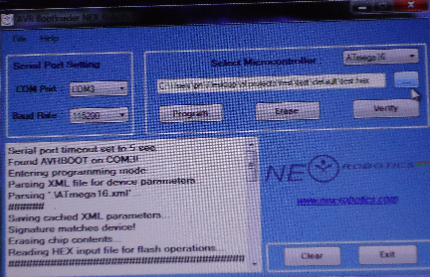

Step 3:
Write codes for gesture recognition in VISUAL STUDIO. Select “Build solution” to generate the codes and later debug them.

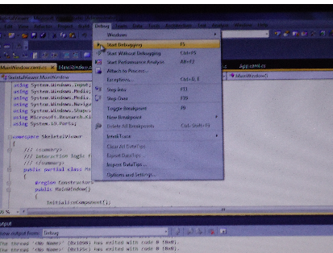

Step 4:
Realtime gestures are made in front of the KINECT SENSOR, which senses the gestures made by already debugged codes and proper corresponding control movements are generated which are transferred to the ROBOT .

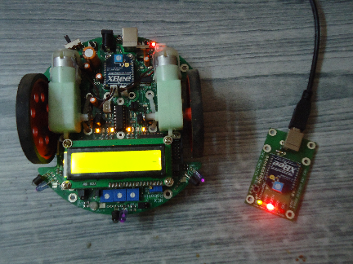

Step 5:
The robot moves accordingly to the gestures.

5. CHALLENGES

- For image-based gesture recognition there are limitations on the equipment used and image noise.
- Images or video may not be under consistent lighting, distinct features of the users may make recognition more difficult.
- The variety of implementations for image-based gesture recognition may also cause issue for viability of the technology to general usage. For example, an algorithm calibrated for one camera may not work for a different camera.
- The amount of background noise also causes tracking and recognition difficulties, especially when occlusions (partial and full) occur.
- Furthermore, the distance from the camera, and the camera's resolution and quality, also cause variations in recognition accuracy.
- In order to capture human gestures by visual sensors, robust computer vision methods are also required, for example for hand tracking and hand posture recognition.

6. CONCLUSION

Our goal is to develop technologies that allow for effective humanrobot teams in dynamic environments. The ability to use the humans natural communication tendencies allows the robot to be more active and safer when working among humans
In this demo, we present an eﬃcient and accurate hand gesture recognition system using Kinect sensor as the input device. Both the depth and color information obtained from Kinect sensor are used for hand detection and movement for the robt , which ensures the robustness of our system.. Besides, the Finger-Earth Mover’s Distance metric employed in our gesture recognition module provides an eﬀective mechanism for recognizing hand shapes with input variations and distortions. Such a hand gesture recognition system provides a robust solution in two real-life HCI applications, which can also be applied to many other hand gesture based HCIs and this methodology can also be extended for more complex robots in the fields of computer vision and robotics.

7. APPLICATIONS

- Gesture controlled robotic nurse:
Gesture driven nurses can be used in all type of works done by a human nurse. It can help the surgeon during surgeries, can provide all the equipments to a surgeon and can even do all types of manual work of a nurse. But being gesture driven, it is more accurate, more specific and more time efficient.
- Gesture driven robot arm:
Gesture driven robot arms are more specific and the precisions formed in angles movements are more better.
- Security systems.
Gesture driven robots can be modified so as to be used in many types of security systems.
- Gesture controlled mechanical systems.
Gesture driven robots can be used in many types of sytems for object perception, object counting etc.

8. REFERENCES
- junsong, z. r. (2009). robust hand gesture recognition with kinect sensor. 3.
- paul doliotis, a. s. (2008). comparing gesture recognition accuracy using color. 4.
- stjepan rajko, g. q. (2008). real-time gesture recognition with minimal training requirements. 4.
- valentino frati, d. p. (n.d.). using kinect for handtracking and rendering in wearable haptics. 2009 , 5.
- pragati garg, n. a. (2009). vision based hand gesture recognition. 3.
- real-time gesture recognition with minimal training requirements. (n.d.).
- rustam rakhimov, p. p. (2010). hand recognitional algorithm.
- srijeyathan, t. ,. (2010). skeletonization in a realtime gesture recognition system. 6.

